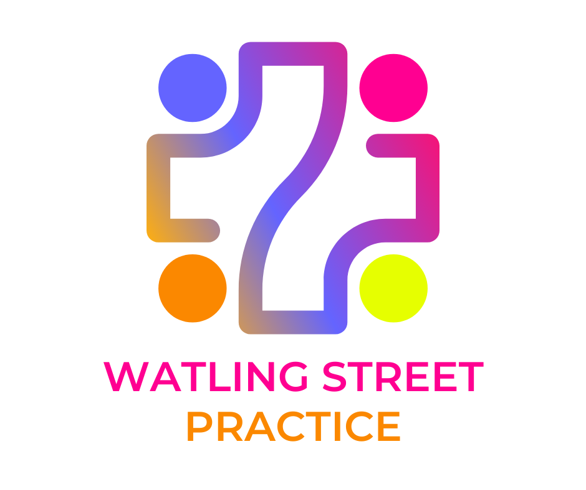
Watling Street Practice

@ Great Holm | Kensington Drive, Milton Keynes, MK8 9HN

@ Stony Stratford | The Health Centre, Market Square, Milton Keynes, MK11 1YA
@ Shenley Church End | Burchard Crescent, Milton Keynes, MK5 6EY

www.watlingstreetpractice.co.uk

Why do GPs sometimes charge fees?

Your questions answered…

Isn’t the NHS supposed to be free?

The National Health Service provides most health care to most people free of charge, but there are exceptions: prescription charges have existed since 1951, and there are several other services for which fees are charged. Sometimes the charge is made to cover some of the cost of treatment, for example, dental fees; in other cases, it is because the service is not covered by the NHS, for example, medical reports for insurance companies.

Surely the doctor is being paid anyway?

It is important to understand that GPs are not employed by the NHS, they are self-employed, and they have to cover their costs – staff, buildings, heating, lighting, etc – in the same way as any small business. The NHS covers these costs for NHS work, but for non-NHS work the fee has to cover the doctor’s costs.

What is covered by the NHS and what is not?

The Government’s contract with GPs covers medical services to NHS patients. In recent years, more and more organisations have been involving doctors in a whole range of non-medical work. Sometimes the only reason that GPs are asked is because they are in a position of trust in the community, or because an insurance company or employer wants to be sure that information provided is true and accurate.

Examples of non-NHS services for which GPs can charge their NHS patients are:
- accident/sickness insurance certificates
- certain travel vaccinations
- private medical insurance reports

Examples of non-NHS services for which GPs can charge other institutions are:
- medical reports for an insurance company
- some reports for the DSS/Benefits Agency
- examinations of local authority employees
- SR1 Form

Is it true that the BMA sets fees for non-NHS work?
The BMA suggests fees for non-NHS work, which is not covered under a GP’s NHS contract, to help GPs set their own professional fees. However, these fees are guidelines only, not recommendations, and a doctor is not obliged to charge the rates suggested.

Why does it sometimes take my GP a long time to complete my form?

Time spent completing forms and preparing reports takes the GP away from the medical care of his or her patients. Most GPs have a very heavy workload – the majority work up to 70 hours a week – and paperwork takes up an increasing amount of their time, so many GPs find they have to take some paperwork home at night and weekends.

I only need the doctor’s signature – what is the problem?

When a doctor signs a certificate or completes a report, it is a condition of remaining on the Medical Register that they only sign what they know to be true. In order to complete even the simplest of forms, therefore, the doctor might have to check the patient’s entire medical record. Carelessness or an inaccurate report can have serious consequences for the doctor with the General Medical Council or even the Police.

What will I be charged?

The BMA recommends that GPs tell patients in advance if they will be charged, and how much. It is up to the individual doctor to decide how much to charge, but the BMA produces lists of suggested fees which many doctors’ use. Surgeries often have lists of fees on the waiting room wall based on these suggested fees.

If you have a form for completion by a doctor, please speak to the reception staff. Please do not give it direct to a doctor

Private Fees
As from 1st Oct 2024

NON-NHS Services |  | Cost from £
GENERAL

Private GP Letters  (no examination)  (Short GP letter to support claims such as: housing, school, college, insurance, COVID recovery  letter, taking medication abroad, etc) | - TWIMC letters (single side/page)  - TWIMC letters with extra pages  - Confirmation of registration | £30  + £5 per extra  £30
Private Sick Note  48 working hours’ notice | - e.g., first 7 days of sickness  - More Complex | £30  £40
Private Prescription | - Travel meds i.e., malaria tablets, or just in case tablets  - Private patient (non-registered) | £20  £20
Private Appointments: | - GP/Minor Illness Nurse  - Nurse/HCA | £60  £40
Child Minding Form | - Ofsted Health Declaration  - AH  - AH2 | £87.50  £73.86  £24.36
Medical Records  For a copy of your health records, the costs are: | - Where a copy of any part of the record is required  - Electronic Record requested a 2nd time covering same time period  - Paper Record requested a 2nd time covering the same time period | Free  £10  £20
EMPLOYMENT

Pre-Employment | - Medical Exam and Report  - Report Only | £165  £100
INSURANCE
Turn around About 15 working days

Medical Insurance Form Completion | - BUPA etc | £40
Medical Insurance | - Report or extract from Medical Records | From £65
Private Medical Health Insurance | - Simple Certificate | £30
Full Medical Report (GPR)  Produced In House | - Insurance companies, employers and solicitors | £100
Full Medical Report (iGPR)  Produced by iGPR | - Fee to insurance companies work via iGPR | £124
DRIVING

Medical Exam and Report  Capacity | - Elderly, HGV, PSV, and Taxi  - Council Report | £150  (paid before appointment)
Drivers Report | - With Medical Exam  - Without Medical exam | £95  £55
TRAVEL

Fitness to Travel/Fly | - Airline Form completion  - With Medical Exam Cons.  - Holiday cancellation form/letter (no examination)  - Holiday cancellation form/letter (with examination)  - Travel Summary | £40  £150  £40  £150  £??
CERTIFICATES

Incapacity | - Certificate of fact | £30
Firearms | - 1st Request  - Renewal | £90  £65
VACCINATIONS

 | - Hep B course of 3 injections (£45.00 each)  Travel /Uni/School/Work  - Pre-Employment Checks Hep B Immunity blood tests  - MEN ACWY | £135.00  prior to vaccines  £50.00  £60.00

